Phone: +49 211 881-4449
Fax: +49 211 881-774449
Mobile: +49 151 40226502
E-Mail: thilo.sagermann@sms-group.com
Thilo Sagermann

PRESS RELEASE

Düsseldorf, March 31, 2016

Straightforward plant modernization with SMS group

Hyundai Steel commissions tandem reversing mill for sections after successful revamping project

At its Pohang works, Hyundai Steel Company, South Korea, has brought back on stream the tandem reversing mill after a successful revamp carried out by SMS group (www.sms-group.com). Commissioning was completed two days ahead of schedule. The revamped mill rolls products such as beams, rails, sheet piles and special sections to improved final geometric tolerances.

SMS group has revamped the rail and section mill in operation since 1993 by installing a new automation system and introducing hydraulically actuated roll adjustment equipment. The two universal stands and the edger were equipped with hydraulic screwdown systems, the stands in the tandem group additionally with axial roll shifting. The hydraulic screwdown systems are controlled by the newly installed TCS® (Technological Control System), which, in addition to controlling the roll gap, allows automatic roll zeroing after a roll change.

The project also included various revamping measures on the reversing roughing stand and the tandem group. Hyundai Steel’s tandem reversing mill was the first of its kind in the world built in the XH® design and featuring just one tandem reversing group. The
recent rebuilt has brought the plant, which has been successfully in operation for more than twenty years, to the latest state of the art. The fact that the comprehensive upgrading measures were implemented during a plant shutdown of only 33 days underlines the SMS group expertise and competence in handling complex modernization projects.
(28 lines of max. 65 characters per line)

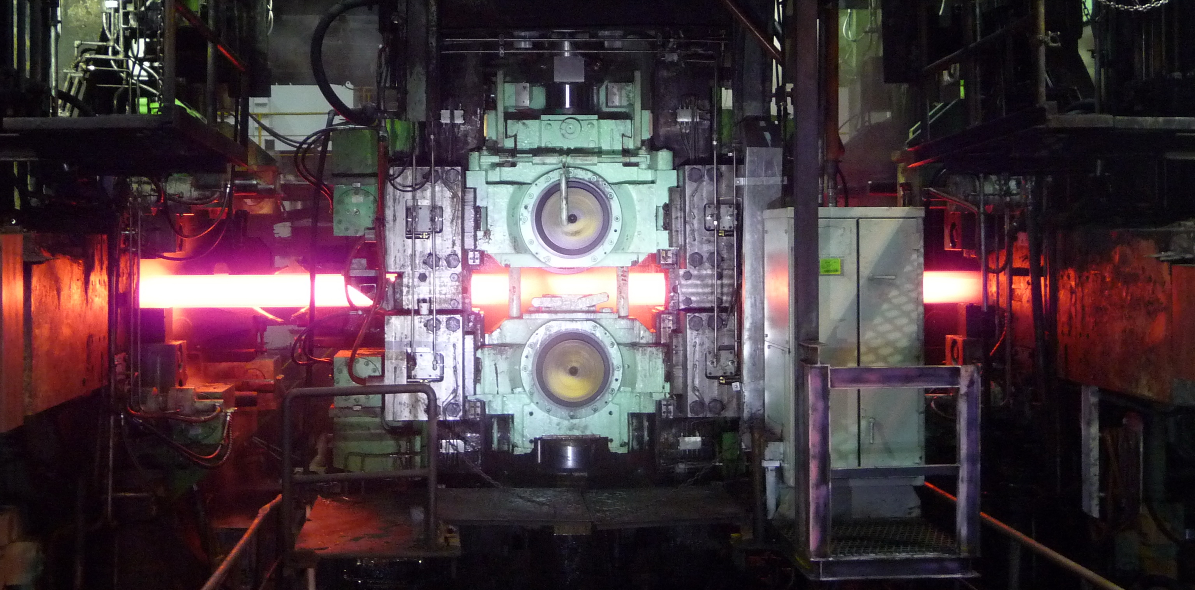
Successful production of the first section on the revamped tandem reversing mill at Hyundai Steel.

Don’t miss out on the latest news, comprehensive background reports and key information about SMS group’s activities. The Push message function of the SMS group App immediately informs you about any new SMS group information posted on the press portal – whether on smart phones or tablets (iOS or Android). Also readable via the App are our SMS group newsletters. Download the App on your mobile terminal device now: www.sms-group.com/app.


