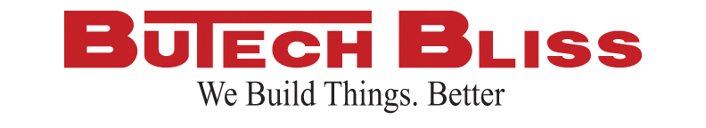

**FOR IMMEDIATE RELEASE**

For more information contact:  
Lisa Liposchak  
Marketing & Advertising Manager  
330-337-0000

**Feralloy Purchases New Butech Bliss Stretch Leveler and**

**Synergy Leveler For Huger, South Carolina Facility**

**Salem, OH – December 7, 2015** – In a effort to continue to deliver the absolute best memory free material to their customers, Feralloy has selected Butech Bliss to upgrade their existing cut-to-length line in Huger, South Carolina. The upgrades will include a Synergy® hydraulic roller leveler, equipped with hydraulic powered independent entry and exit roll settings, closed loop system to compensate for machine deflection and enhanced operator friendly controls. The roller leveler also features a quick change roll cartridge system and scale removal conveyor system. The patent pending Butech Bliss stretch leveler features a 45 foot stretch bed and 1,850 tons of stretching force. The stretch leveler also is equipped with the Hawkeye™ Flatness Detection System which consists of an array of sensors mounted across the width of the strip to measure flatness deviations and deliver instantaneous feedback to the operator. Installation of the new Synergy® leveler and stretch leveler will be completed in the second quarter of 2016. The equipment will process carbon steel up to 0.75 inch thick by 74 inches wide. The upgrades to the cut-to-length line will enhance Feralloy’s ability to process hot rolled, pickled and oiled material and produce memory-free panel flat product for OEM’s that laser cut parts and components. The Huger facility is strategically located to serve manufacturers in the Southeast.

**About Butech Bliss**

*Butech Bliss provides innovative engineering, manufacturing and field services to the metals industries from the company’s 400,000 square foot Technology Center located in Salem, Ohio. For more information, visit* [*www.butechbliss.com*](http://www.butechbliss.com)*.*

**About Feralloy Corporation**

*Feralloy Corporation processes flat rolled steel in the United States and Mexico. Feralloy Corporation was founded in 1954. It operates as a subsidiary of Reliance Steel & Aluminum Company. Feralloy has ten locations serving United States and Mexico. For more information, visit* [*www.feralloy.com*](http://www.feralloy.com)

